Given the root of a binary tree, each node has a value from 0 to 25 representing the letters 'a' to 'z': a value of 0 represents 'a', a value of 1 represents 'b', and so on.

Find the lexicographically smallest string that starts at a leaf of this tree and ends at the root.

*(As a reminder, any shorter prefix of a string is lexicographically smaller: for example, "ab" is lexicographically smaller than "aba".  A leaf of a node is a node that has no children.)*

**Example 1:**

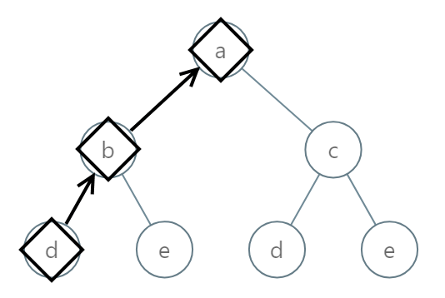

**Input:** [0,1,2,3,4,3,4]

**Output:** "dba"

**Example 2:**

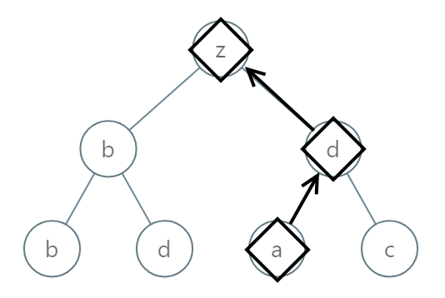

**Input:** [25,1,3,1,3,0,2]

**Output:** "adz"

**Example 3:**

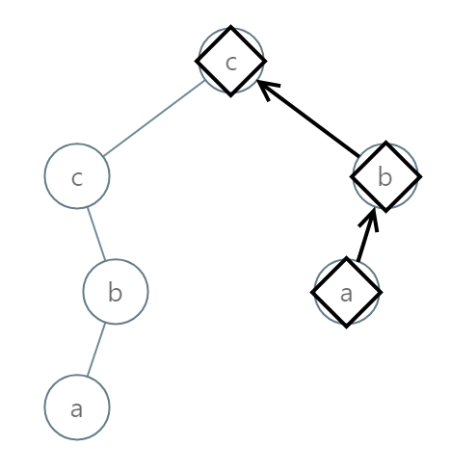

**Input:** [2,2,1,null,1,0,null,0]

**Output:** "abc"

**Note:**

1. The number of nodes in the given tree will be between 1 and 8500.
2. Each node in the tree will have a value between 0 and 25.